Google Apps for Education includes email as well as other productivity apps like calendar, editors, chat and video collaboration. We already use this solution for student emails. So, adding another 500 or so for faculty and staff should be familiar. Note the items to research to round out the solution.

**Benefits**

1. Google Apps for Education is free. (Free, as in free beer.)  
   http://www.google.com/a/help/intl/en/edu/index.html

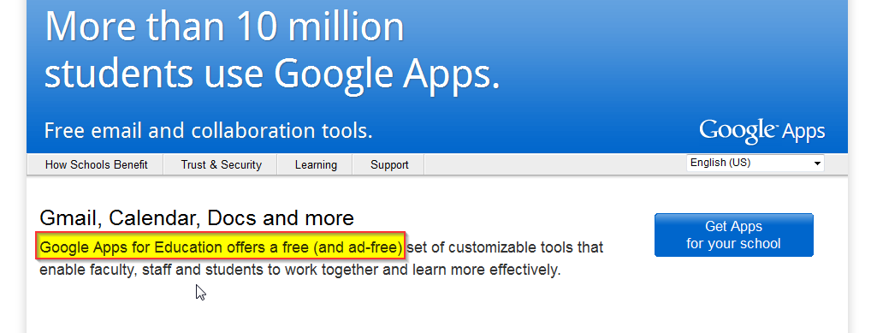

1. Google data center is located in Lenoir, so why not use a local technology.
2. Google Apps support “dual delivery” which allows the email to be sent to both the primary and secondary mail servers to allow for transition from legacy mail system to Google Apps.
3. The [Google Email Settings API](http://code.google.com/googleapps/domain/email_settings/developers_guide_protocol.html) exists for programmatically control over user settings.
4. The Google Apps Provisioning API (latest version is 2.0) exists to programmatically create, retrieve, update, and delete user accounts. This could be leveraged to automate creation of new student accounts, modify email addresses to reflect correct last name, and other manual business processes.
5. The Google single sign-on API (or OpenID) allows Google Apps to sync logins with existing login portal/SSO application.

**Items to research**:

1. Do we have an existing Google Apps for Education account? Does this require a new account?
2. We would add many staff, faculty, etc. accounts. Require a solution to migrate userids, accounts details, email, lists, etc. from GroupWise to Google Apps. (The [Email Migration API](http://code.google.com/googleapps/domain/email_migration/developers_guide_protocol.html) exists to assist with migration of email from legacy to Google Apps.)
3. How does this impact, integrate with, and otherwise break other applications within CCC&TI (Blackboard, WebAdvisor, and Colleague)?
4. Investigate a scheme/algorithm for userids that reduces/eliminates need to change them.   
   [Generic Userid Investigation](http://ist.uwaterloo.ca/cs/userids/useridrecommendations.html)